Concurrency in Distributed Systems

Videos :

Concept and coding :

<https://www.youtube.com/watch?v=D3XhDu--uoI&ab_channel=Concept%26%26Coding-byShrayansh>

Gatesmashers :

<https://www.youtube.com/watch?v=UsqtDD1VriY&ab_channel=GateSmashers>

<https://www.youtube.com/watch?v=1pUaEDNLWi4&ab_channel=GateSmashers>

<https://www.youtube.com/watch?v=pZExswIjVsk&ab_channel=GateSmashers>

<https://www.youtube.com/watch?v=z8Yqn91akV8&ab_channel=GateSmashers>

Notes:

1. In single instance system
   1. Synchronization
      1. Synchronized block (critical section) : Mutex, locking
      2. Only one thread can enter the critical section (i.e. access shared resource)
2. In Distributed systems
   1. Different process running on different nodes
      1. Can’t use normal synchronization (synchronization handles multiple threads, not multiple process. Concept : Each process has multiple threads)
   2. Locking
      1. Optimistic and Pessimistic locking
         1. Concepts
            1. Transaction

We need Atomicity (A) and Isolation(I) of ACID property

A : : All or nothing / commit or abort

I : Each transaction fees like it is the only one running

* + - * 1. Locking types

Read lock (Shared Lock)

Multiple Read locks at a time, no write lock at that time

Write lock (Exclusive lock)

No other Read or Write lock at that time

* + - * 1. Concurrency problems

Dirty Read

One transaction can read a transient value, i.e. value that is changed but not yet committed (this value can get rolled back or changed further)

Cause: Read before Commit

Solution: Read committed (i.e. take shared lock while reading, Exclusive lock while writing. Shared lock lasts only while reading, Exclusive lock lasts till end of transaction)

Non-Repeated read

Within same transaction, multiple reads of same record, gave different value

Cause: Multiple commits by other transaction

Solution: Repeated read (i.e. Shared lock for read till end of Transaction, Exclusive lock for write till end of transaction)

Phantom Read (for range-based queries)

In same transaction, Multiple range-based reads gives different number of records

Cause: other transaction inserted/deleted some records during read

Solution: Serializable (shared/exclusive lock over range of rows)

1. 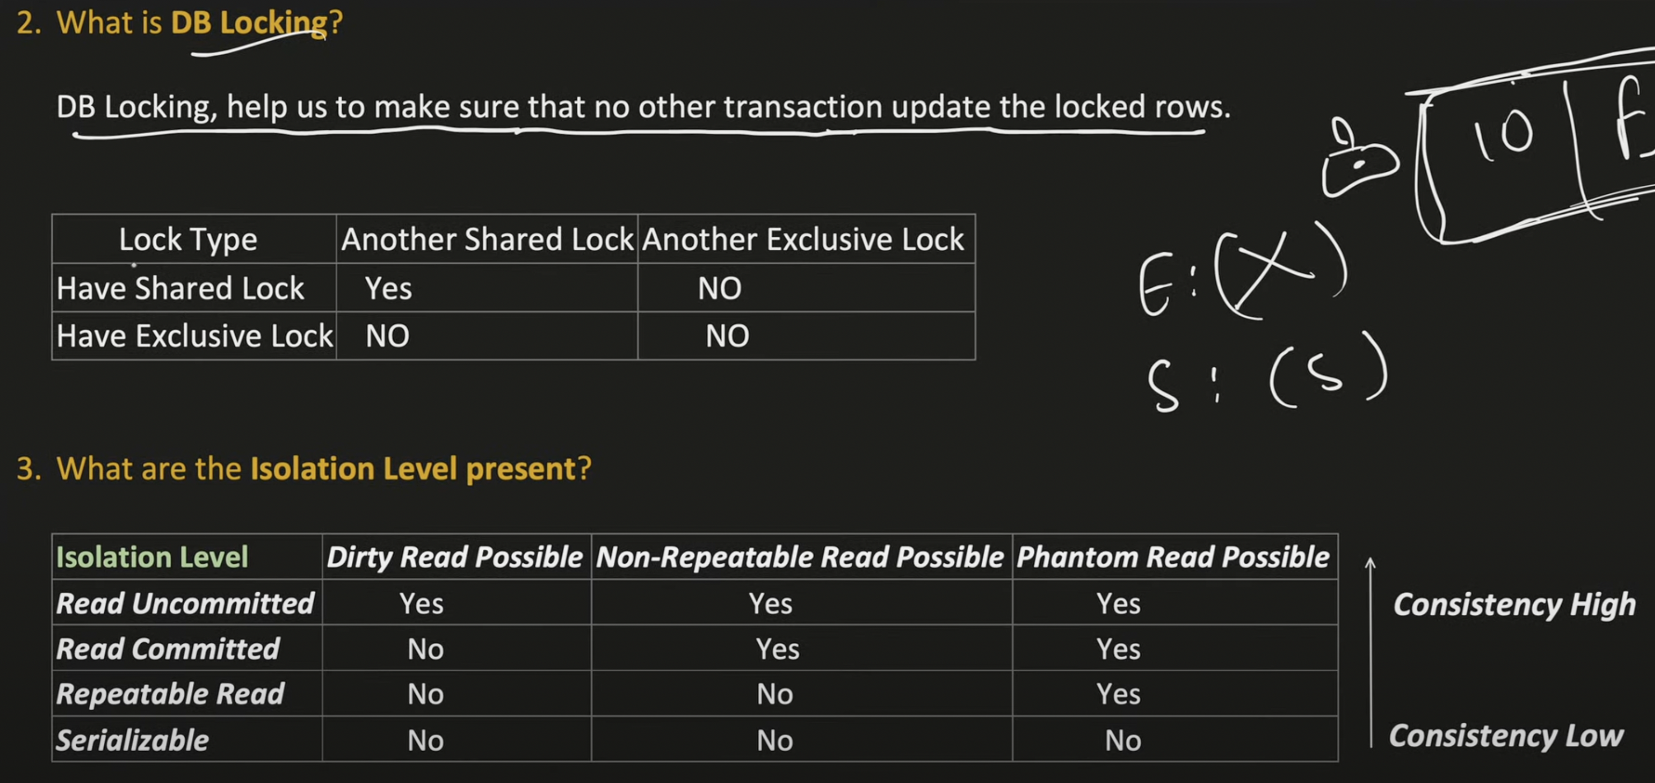
   1. **Note:** 
      1. **Typo in image : It’s concurrency, not consistency**
2. 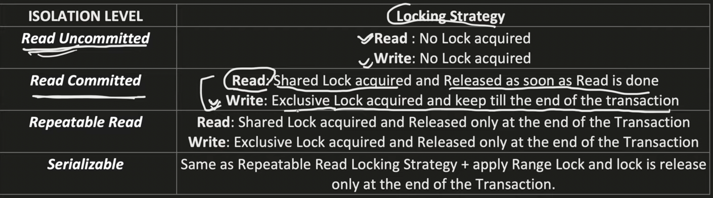
   * 1. First two are optimistic locking, next 2 are pessimistic locking
3. 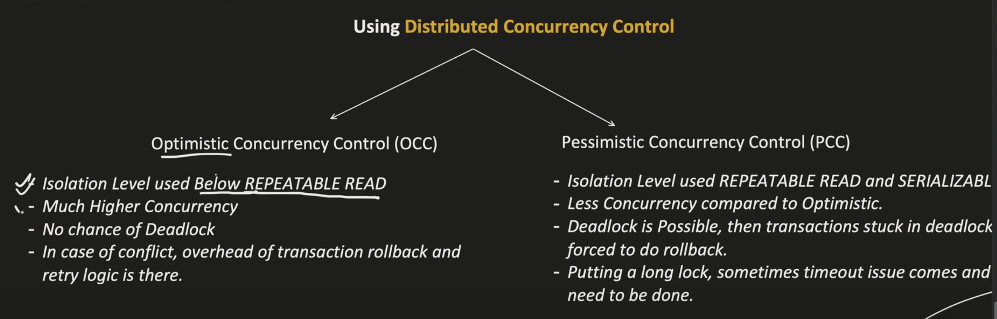
4. 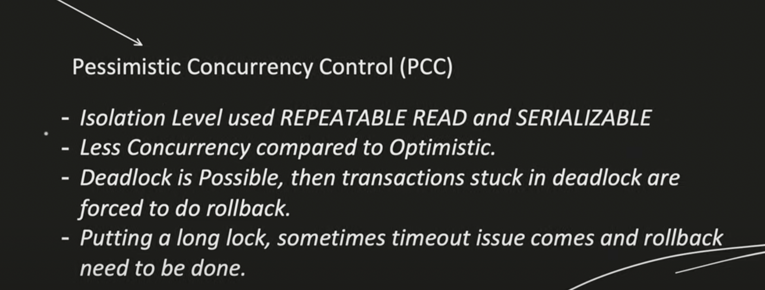

These concepts are all fundamental to **database concurrency control** and **transaction management**. They define how databases handle multiple transactions executing simultaneously while maintaining **ACID properties** (Atomicity, Consistency, Isolation, Durability). Below is a structured breakdown of how they relate:

**1. DB Isolation Levels & Read Phenomena**

Different isolation levels control which **read phenomena** are allowed:

| **Isolation Level** | **Dirty Read** | **Non-Repeatable Read** | **Phantom Read** |
| --- | --- | --- | --- |
| **Read Uncommitted** | ✅ Yes | ✅ Yes | ✅ Yes |
| **Read Committed** | ❌ No | ✅ Yes | ✅ Yes |
| **Repeatable Read** | ❌ No | ❌ No | ✅ Yes |
| **Serializable** | ❌ No | ❌ No | ❌ No |

* **Dirty Read**: Reading uncommitted data (later rolled back).
* **Non-Repeatable Read**: A row changes between two reads in the same transaction.
* **Phantom Read**: New rows appear between two reads in the same transaction.

**2. Concurrency Control Approaches**

Two main strategies ensure transactions execute correctly in parallel:

* **Optimistic Concurrency Control (OCC)**
  + Assumes conflicts are rare.
  + Transactions proceed without locking, but **validate at commit time**.
  + If validation fails (due to conflicts), the transaction aborts.
  + Works well with low contention.
* **Pessimistic Concurrency Control (PCC)**
  + Assumes conflicts are common.
  + Uses **locks** to prevent conflicts (e.g., read/write locks).
  + Examples: **Two-Phase Locking (2PL)**, Strict 2PL, Rigorous 2PL.
  + Risk : **deadlocks**

**3. Locking Protocols (Pessimistic Approach)**

* **Two-Phase Locking (2PL)**
  + **Growing Phase**: Acquire locks, but cannot release any.
  + **Shrinking Phase**: Release locks, but cannot acquire new ones.
  + Ensures **serializability** but can cause **deadlocks**.
    - **serializability** is **Goal** of concurrency control. A schedule is **serializable** if it is **equivalent to some serial order**. Can be verified via **conflict serializability** (check for conflicting ops and order them).
* **Strict 2PL**: All locks held until commit/abort (no cascading aborts).
* **Rigorous 2PL**: All locks held until commit (strict + no shrinking phase).
* **Basic vs Conservative vs Strict vs Rigorous 2PL**:
  + **Basic 2PL**: Allows shrinking phase (vulnerable to cascading aborts).
    - Problems : Cascading rollback, Deadlock, Starvation
  + **Conservative 2PL**: Locks all needed data upfront (deadlock-free but impractical).
    - Fixes Deadlock
  + **Strict 2PL**: No dirty reads (Transaction holds all **write locks** until it commits/aborts).
    - Fixes cascading rollback
  + **Rigorous 2PL**: All locks held until commit (strict + no shrinking).

**Issues in Locking**

**🧱 Deadlock**

* Circular waiting: T1 waits for T2, T2 waits for T1.

**🦴 Starvation**

* A transaction **never gets a lock** due to others always getting priority.

**4. Conflicts & Deadlocks**

* **Conflict**: Two transactions try to access the same data in incompatible ways (e.g., write-write, read-write).
* **Deadlock**: Circular wait between transactions (e.g., T1 waits for T2, T2 waits for T1).
  + **Detection**: **Wait-for Graph** (cycle = deadlock).
  + **Resolution**:
    - **Die-Wait**: Older transactions wait, younger ones abort.
    - **Wound-Wait**: Older transactions "wound" (abort) younger ones.
    - **Timeout**: Abort if waiting too long.

**5. Cascading Aborts & Recoverability**

* **Cascading Abort**: One abort forces others to abort (due to dirty reads).
  + • If T1 reads dirty data from T2, and T2 aborts, T1 also must abort.
  + • **Strict 2PL** prevents this by holding **write locks until commit**.
* **Irrecoverable Schedule**
  + If T1 reads dirty data from T2, and T1 commits, but later T2 aborts, T1 can’t abort now, irrecoverable.
  + **Strict 2PL** prevents this : **Recoverable Schedule**: Transactions commit only after those they read from commit.

**6. Distributed Transactions (2PC) -** Commit Protocol in Distributed Systems

* **Two-Phase Commit (2PC)**: Ensures atomicity in distributed systems.
  + **Phase 1 (Prepare)**: Coordinator asks participants to prepare to commit.
  + **Phase 2 (Commit/Abort)**: Decision is finalized. If all agree → commit. Else → abort.
  + Issues: **blocking** if coordinator crashes mid-protocol.

**7. Starvation**

* **Starvation**: A transaction is indefinitely delayed (e.g., due to unfair lock scheduling).
* **Solutions**: Fair scheduling (e.g., FIFO queues).

**8. Other Concepts**

* **Multi-Version Concurrency Control (MVCC)**: Keeps multiple versions of data to avoid locks (used in PostgreSQL).
  + **NO locking as each transaction working on separate copy, reduce conflicts**.
* **Snapshot Isolation**: Transactions see a consistent snapshot (prevents dirty reads, but phantoms possible).
* **Timestamp Ordering**: Assigns timestamps to order transactions.

**How It All Fits Together**

1. **Concurrency Control** (Optimistic/Pessimistic) → Ensures correct execution.
2. **Isolation Levels** → Define which phenomena are allowed.
3. **Locking (2PL, Strict, Rigorous)** → Prevents conflicts but may cause deadlocks.
4. **Deadlock Handling** (Wait-for Graph, Wound-Wait, Timeout) → Resolves circular waits.
5. **Recovery & Atomicity** (2PC, Cascading Aborts) → Ensures transactions commit/abort correctly.

This framework ensures databases balance **correctness** (serializability) with **performance** (concurrency). Missing concepts can include **index locking**, **predicate locking** (for phantom reads), or **optimistic snapshot validation**.